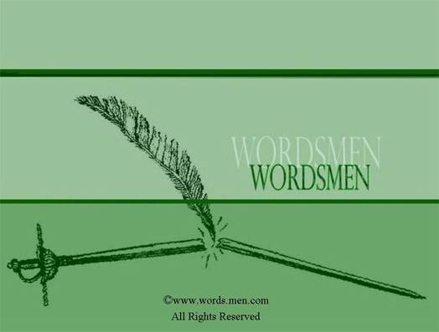
“Wordsmen” Say it right - Say it well

We believe communication is a fine art. And everything is open to interpretation.
Our goal is to provide accurate, well written, and well thought out communications, so that whatever you say will be interpreted by those who read it as you intended.
Whether it be articles, resumes, business or personal letters, forms, applications, contracts or business plans, we have the right words for your needs.
It’s all semantics.
In today’s complex world it’s hard to keep up with the demands of personal and business communication, and even harder to know how best to interpret your ideas to others. Let us help.
Say it right Say it well.
Ask yourself this;
1. How well do I write?
2. Are others able to understand what it is I am trying to say?
3. Is my schedule too busy to get to all my correspondence?
4. Does my writing represent just how intelligent I really am?

If not, maybe we can help.
We will help you say it right and say it well.

